A Recipe For:

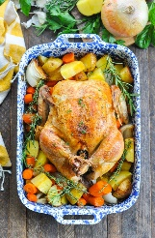 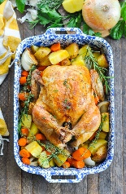

# **Roasted Chicken with Vegetables**

**From the Kitchen of:** Mom

**Servings:** 4

**Prep Time:** 2 hours 45 minutes **Bake Time:** 20 minutes **Bake Temp:** 350

**Ingredients:**

* 1 whole chicken
* 1 lemon, juiced
* 4 garlic cloves, minced or pressed
* 1 tsp paprika
* 1 tsp dried oregano
* 1 tsp salt
* ½ tsp pepper
* 4 tsp olive oil
* 2-3 yellow potatoes
* 2-3 carrots
* 1 med yellow onion (optional)

**Instructions:**

1. Place chicken in a roasting pan and drizzle over the lemon juice, making sure to cast the entire chicken
2. In a small bowl, combine the garlic, paprika, oregano, ½ tsp salt, pepper and 2 tsp oil. Mix well. Rub evenly over the surface of the chicken. Cover and let marinate at room temperature for 1-1 ½ hours or chill overnight (return to room temperature before roasting).
3. Peel the potatoes, carrots and onion and cut all vegetables into large chunks. Place around the chicken in the roasting pan and drizzle with the remaining 2 tsp olive oil and ½ tsp salt.
4. Put the pan in a col oven and set the temperature to 350. Roast about 1 ½ - 2 hours, or until the chicken reaches an internal temperature of 165. Use a meat thermometer, or prick with a skewer and the juices should be clear. Remove from the oven and let the chicken rest for 15 minutes before carving.
5. Carve the chicken and serve with the roasted vegetables